Non-CA Package
- STD_PDF_CONV
- FILE_SORT

- STD_PDF_CONV
- This Package creates the PDF for the Non- CA files available in Source Folder(Reports Folder) and keep both PDF and text file in the same folder.
- It will not create PDF for CA Report files, we have Separate package with RDL for the CA Report PDF generation.

Package Flow
Task 1 – Check Last Run Status
- It is the SQL task , it checks the status from ETL_PKG_RUN_LOG table where the current package is in running status or in successful status.
- It will proceed the flow only when the status is in ‘S’. Or else it will end the package by directing into Stop Process Task.
Query
Select COUNT(1) CNT from [ETL_PKG_RUN_LOG]
where STAT in('R') and [PKG_NME]='STD_PDF_CONV'

- The Result Set of this Query will be stored in CHK_FLG Variable and will be used in Precedence Constraints to proceed the further flow

Task 2 – PKG Exec starts
- It is SQL task, It will make entry in ETL_PKG_RUN_LOG table with Package name, Time and with status as ‘R’(Running)
- Once the Task succeed. Package flows to the next task

Query
INSERT INTO ETL_PKG_RUN_LOG(PKG_NME,DESCRIPTION,PRCS_DTE,STAT)
Values ('STD_PDF_CONV','The Package Execution Started',getdate(),'R')

Task 3 – Truncate Table
- It is the SQL task, To truncate the TB_SRC_FILE_SORT_PDF.
- This Table is the Temporary table, used to hold the entries for PDF generation and will truncate the table for every package starts.
- The Permanent UI Table we have is TB_SRC_FILE_SORT. Which has all the entries, when the user request to download any file it will fetch the entries from here and pick the files from Mirror Folder.

Query
TRUNCATE TABLE TB_SPF_FILE_SORT_PDF

Task 4 – Get Files Name
- It is Process execute task, which uses the Power shell script to fetch all the file list from the Reports path (Source path) and generate the out file as FileName_PDF with all the file details.

PowerShell Script
(Get-ChildItem -Path "\\vwmazqaebtap02\Reports\govOrganizationReports" -Recurse -Include *.* | Format-Table -Wrap -AutoSize -HideTableHeaders @{Name='FullName';Expression={$_.FullName +'|'}}, @{Name='LastWriteTime';Expression={'|' +$_.LastWriteTime.ToString('yyyy-MM-dd HH:mm:ss') }}|Out-String -Width 10000).trim()| out-file F:\FileName_PDF.txt
Script Explanation
- Get- ChildItem -Path “” This Cmdlet will get the files and directory(Folder) names from the given path.

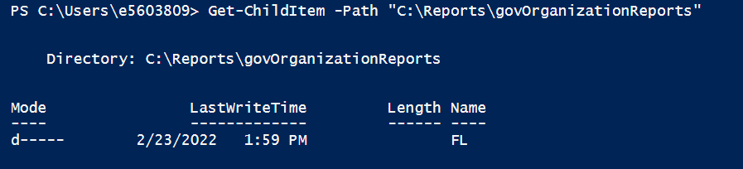

- -Recurse It is used to reoccur the fetch continuously into its subfolders Until no items available.
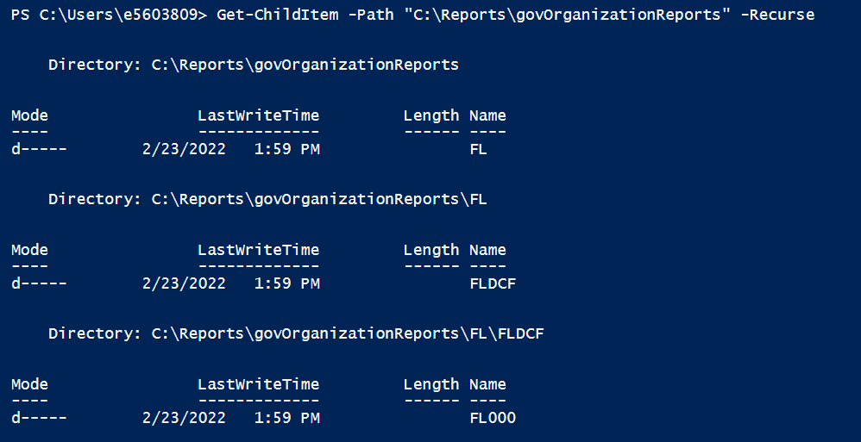

- -include *.* This command will act as an wildcard search and fetch only the files or folders which has . character in its name and avoid other names available in the given path. In order to have a specified fetch we will use this command.

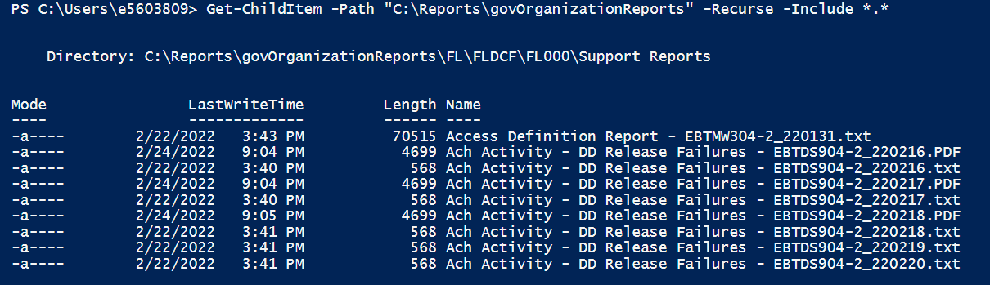

- Format-Table -Wrap -AutoSize -HideTableHeaders
    - The Format-Table is used to format the output as Table.
    - The Wrap is used to Displays text that exceeds the column width on the next line. By default, text that exceeds the column width is truncated.
    - AutoSize adjusts the column size and number of columns based on the width of the data.
    - HideTableHeaders used to omits the table header

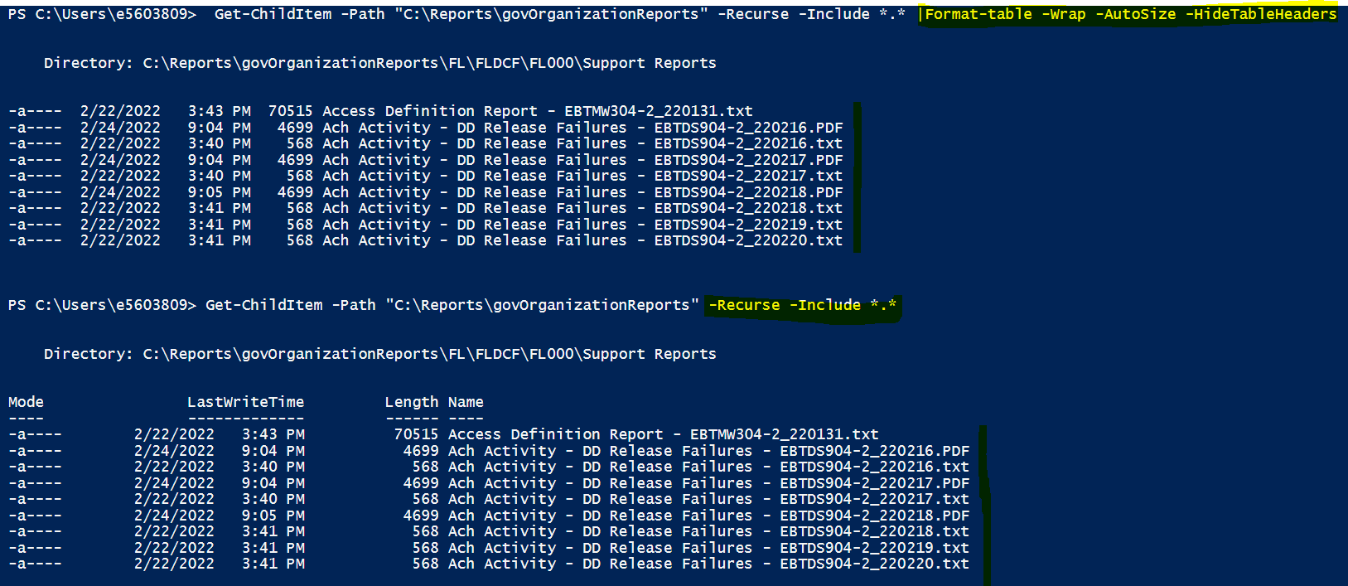

- @{Name='FullName';Expression={$_.FullName +'|'}}, @{Name='LastWriteTime';Expression={'|' +$_.LastWriteTime.ToString('yyyy-MM-dd HH:mm:ss') }}

- The Name=’FullName’
Here the Name is the name of the file with extension, FullName is file including the path and the extension, In order to get complete file path along with its name we use as above

- Expression={$_.FullName +'|'}}
we use expression to format the set of character or string with extensions like pipeline as given above.

- @{Name='LastWriteTime';Expression={'|' +$_.LastWriteTime.ToString('yyyy-MM-dd HH:mm:ss') }}
The LastWriteTime is PowerShell command used to get the current date and time and using expression we are converting the LastWriteTime to string with the specified format.

- Out-String -Width 10000).trim()| out-file F:\FileName_PDF.txt
- Out-String It will convert the input objects into string
- -Width 10000 -Width specifies the no of character in each line of the file, if it is more than specified length then it will truncate.
- .trim() It is used to remove the leading and trailing spaces from the fetched string data.
- out-file F:\FileName_PDF.txt This out-file will send the output to the file in the given file


FileName_PDF.txt

Task 5 – Load File Names
- It is the Script Task, The script code will be in C#. The Main workability of this task is to get the data from the outfile i.e. FileName_PDF.txt and load it in the Temporary table File_Sort_PDF
- We have 3 Read/write Variable in these that are
- Connection String – Which hold the Database connection string as below

Data Source=10.7.142.17;Initial Catalog=EBT;Integrated Security=SSPI;

- Server Path – In this we will give the Application Reports folder path (from DB server) which having the Reports that require to generate PDFs
Initially we will give the path into the string Variable and then we will place that Variable into a expression of another object variable. This is because inside the script we will use this variable with different operator hence it order to avoid any datatype related issue we will be converting it to expression and converting the datatype into Object

- Local Path – In this we store the Local path of the application reports folder(destination folder) in base of Application Server. As like we do for server path variable we convert the value to object type as below.

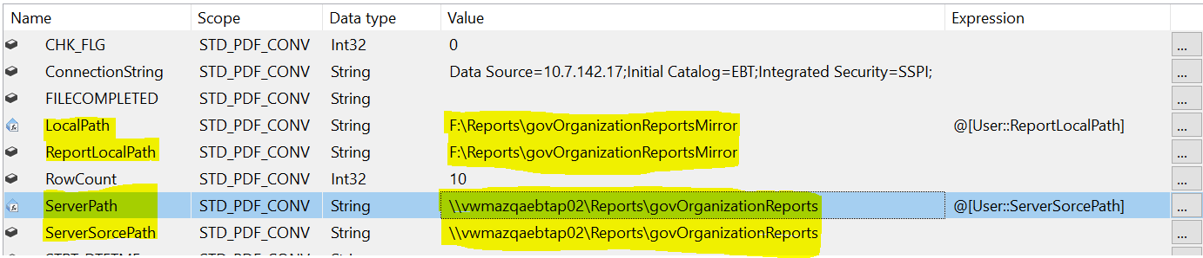

Script code & Explanation:

Script Task Code Link

Task 6- Retail Useful:
- It is the SQL task, which is used to remove the files entry in PDF table that are apart from .txt, .csv, .pdf i.e. which are not in standard format.
Query:
DELETE FROM TB_SPF_FILE_SORT_PDF
WHERE FILENAME1 NOT LIKE '%.txt%' AND FILENAME1 NOT LIKE '%.pdf%' AND FILENAME1 NOT LIKE '%.csv%'
- Until now in PDF table we have entry only for two columns Filename1 and Prcs_date.

Task 7- Get Other info:
- It is SQL Task, which is used to make entries for other columns in PDF table but except for Lvl1, Lvl2 and Lvl3. All the columns will be updated from Filename1 Column.
Query:
UPDATE
TB_SPF_FILE_SORT_PDF
SET
DATETIME = REVERSE(SUBSTRING(REVERSE(FILENAME1), CHARINDEX('.',REVERSE(FILENAME1))+1, CHARINDEX('_',REVERSE(FILENAME1)) - CHARINDEX('.',REVERSE(FILENAME1))-1)),

GENERATED_DATE= SUBSTRING((REVERSE(
SUBSTRING(REVERSE(FILENAME1), CHARINDEX('.',REVERSE(FILENAME1))+1, CHARINDEX('_',REVERSE(FILENAME1))-CHARINDEX('.',REVERSE(FILENAME1))-1)))
,0,7),

GENERATED_TIME = CASE WHEN LEN(REVERSE(SUBSTRING
(REVERSE(FILENAME1), CHARINDEX('.',REVERSE(FILENAME1))+1,
CHARINDEX('_',REVERSE(FILENAME1))-CHARINDEX('.',REVERSE(FILENAME1))-1)))>6
THEN SUBSTRING((REVERSE(
SUBSTRING(REVERSE(FILENAME1), CHARINDEX('.',REVERSE(FILENAME1))+1,
CHARINDEX('_',REVERSE(FILENAME1))-CHARINDEX('.',REVERSE(FILENAME1))-1)))
,8,5) ELSE '' END,

FILE_EXT= RIGHT(FILENAME1,3),

RPT_NME =REVERSE(SUBSTRING
(REVERSE(FILENAME1),CHARINDEX('.',REVERSE(FILENAME1),0)+1,
CHARINDEX('\',REVERSE(FILENAME1),0)-CHARINDEX('.',REVERSE(FILENAME1),0)-1)),

PRCS_DTE = GETDATE()

FROM TB_SPF_FILE_SORT_PDF

Task 8 – Update Hierarchy:
- It is SQL Task, used to make the entries for Lvl1, Lvl2, Lvl3, Rpt_cat & Ver no of the temporary tables.
- In above query we have used CTE to store the temporary result set in Temp table and to update the hierarchy data in table.

;WITH T(FILENAME1,FILENME, STARTS, POS) AS (
SELECT FILENAME1, SUBSTRING(FILENAME1,CHARINDEX('govOrganizationReportsMirror\',FILENAME1),
LEN(FILENAME1)) FILENAME1,
1,
CHARINDEX('\', FILENAME1) POS
FROM TB_SPF_FILE_SORT_PDF
UNION ALL
SELECT FILENAME1,FILENME, POS + 1, CHARINDEX('\', FILENME, POS + 1)
FROM T
WHERE POS > 0
)
SELECT
*, SUBSTRING(FILENME, STARTS, CASE WHEN POS > 0 THEN POS - STARTS ELSE LEN(FILENME) END) TOKEN,ROW_NUMBER()OVER(PARTITION BY FILENME ORDER BY STARTS) RNO INTO #TEMP
FROM T
ORDER BY FILENME, STARTS

UPDATE TB_SPF_FILE_SORT_PDF
SET LVL1=A.TOKEN
FROM #TEMP A
JOIN TB_SPF_FILE_SORT_PDF SORT ON A.FILENAME1=SORT.FILENAME1
WHERE RNO=3 AND SORT.FILENAME1=A.FILENAME1

UPDATE TB_SPF_FILE_SORT_PDF
SET LVL2=A.TOKEN
FROM #TEMP A
JOIN TB_SPF_FILE_SORT_PDF SORT ON A.FILENAME1=SORT.FILENAME1
WHERE RNO=4 AND SORT.FILENAME1=A.FILENAME1

UPDATE TB_SPF_FILE_SORT_PDF
SET LVL3=A.TOKEN
FROM #TEMP A
JOIN TB_SPF_FILE_SORT_PDF SORT ON A.FILENAME1=SORT.FILENAME1
WHERE RNO=5 AND SORT.FILENAME1=A.FILENAME1

UPDATE TB_SPF_FILE_SORT_PDF
SET RPT_CAT=A.TOKEN
FROM #TEMP A
JOIN TB_SPF_FILE_SORT_PDF SORT ON A.FILENAME1=SORT.FILENAME1
WHERE RNO=6 AND SORT.FILENAME1=A.FILENAME1

UPDATE A
SET A.VER_NBR = B.VER_NBR+1
FROM TB_SPF_FILE_SORT_PDF A
JOIN TB_SPF_RPT_VER B ON A.FILENAME1 = B.FILENAME1

UPDATE TB_SPF_FILE_SORT_PDF
SET TB_SPF_FILE_SORT_PDF.VER_NBR = 1
WHERE TB_SPF_FILE_SORT_PDF.VER_NBR IS NULL

Query Explanation:
- The below query used in the query definition part along in union all with pdf table to retrieve the column data part by part using \ in the Filename1 column. As we seen in below screenshot each file entries will be recursive continuously for each / appearance and until the last appearance of /.

SELECT FILENAME1,FILENME, POS + 1, CHARINDEX('\', FILENME, POS + 1)
FROM T
WHERE POS > 0

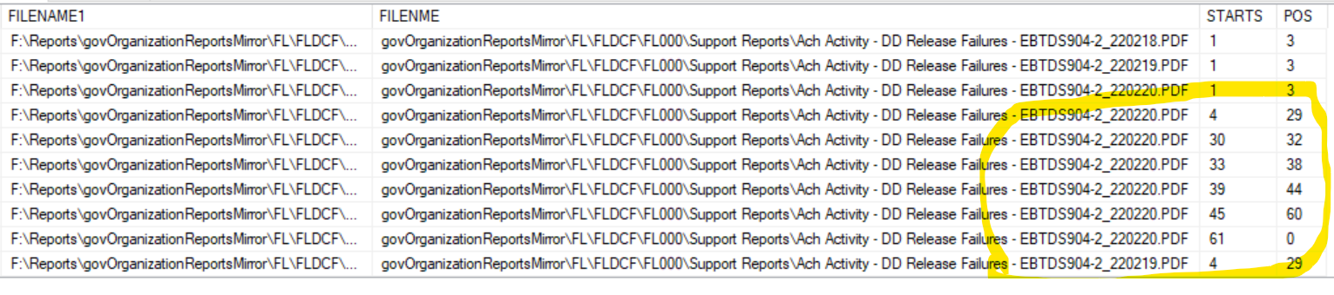

- In next select statement we use case when condition to filter the column data by row wise

SELECT
*, SUBSTRING(FILENME, STARTS, CASE WHEN POS > 0 THEN POS - STARTS ELSE LEN(FILENME) END) TOKEN,ROW_NUMBER()OVER(PARTITION BY FILENME ORDER BY STARTS) RNO INTO #TEMP
FROM T
ORDER BY FILENME, STARTS
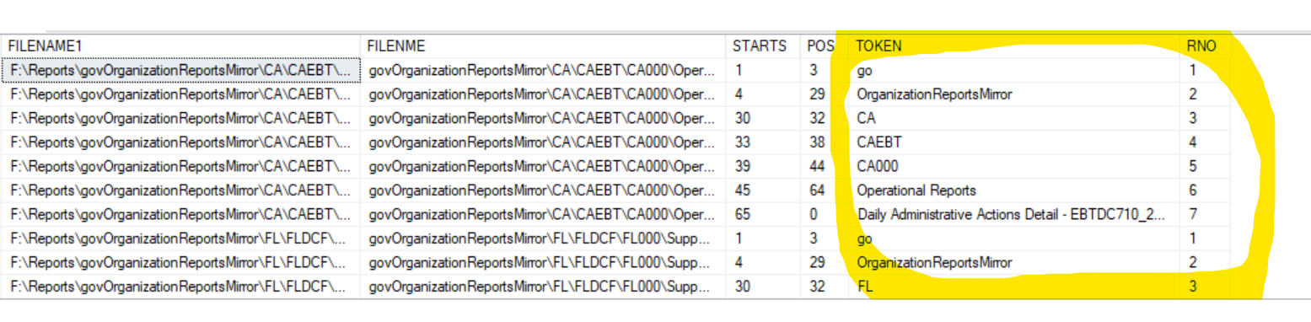
As shown in above screenshot the entries will get separated by column wise with row number, all these row number will be same for distinct entries. So with the help of these row number we fetch the data update to their individual columns.
Task 9 – Standard KS:
- It is the script task, used for PDF generation. In this we generate PDF only for the standard report, the wider report PDF generation will be carried out in below next task.
- We used same Read only variable connection string, local path, server path as we used in before load filename task.
Script Task Query 1 – Explanation:
SELECT distinct FLE.RPT_NME,
REPLACE(FLE.FILENAME1,'" + localPath + "','" + serverPath + "') AS SRC_PATH,
isnull (CASE WHEN FLE.LVL1 = 'CA' AND FLE.RPT_CAT LIKE 'FIS%' THEN 'PAGE:' ELSE SH.PAGE_PARSER_STRING END ,
isnull(META.PAGE_SPLIT,'')) PAGE_PARSER_STRING,
isnull(CLMN_HDR1,'') CLMN_HDR1,
isnull(CLMN_HDR2,'') CLMN_HDR2,
isnull(CLMN_HDR3,'') CLMN_HDR3,
isnull(CLMN_HDR4,'') CLMN_HDR4 FROM TB_SPF_FILE_SORT_PDF FLE
JOIN TB_SRC_STATE_DIM SH ON FLE.LVL1=SH.STATE_CDE
left JOIN TB_SRC_RPT_METADATA_DTL META
on META.RPT_NME=left(FLE.RPT_NME,(len(FLE.RPT_NME)-7))
left join (select distinct RPT_NME from TB_EBT_NON_STD_RPT) A
on FLE.RPT_NME LIKE '%'+A.RPT_NME+'%'
WHERE (FLE.LVL1 != 'CA' OR (FLE.LVL1 ='CA' AND FLE.RPT_CAT LIKE 'FIS%'))
and CONCAT(FLE.LVL1,LVL2,LVL3,FLE.RPT_NME)
NOT IN(SELECT CONCAT(LVL1,LVL2,LVL3,RPT_NME)
FROM TB_SPF_FILE_SORT_PDF where FILE_EXT = 'PDF') AND FLE.FILE_EXT = 'TXT' and A.RPT_NME is null;

- In the above query, we used PDF as the base table in join with Metadata table , state dimension table and Non-Std report table.
- Using this query we are filtering the Non-CA entries, then the already PDF generated entries, then the wider reports.
- In Line 2, we used case when condition to get the entries for CA Internal Reports to generate PDF for those reports also, Remember only the CA reports will be taken care by their respective CA Packages. All the CA internal Reports will be take care only by the EIMS ETLs, the CA Internal Reports have the pagination as PAGE: like Non-CA reports ,not as normal standard CA files like PAGE.
- To filter wider report entries , we have left joined the Non-std table with Like operator which will combine both the data, and display null for the standard report which are not available in Non-standard table. Using Rpt_nme =Null condition we are filtering only the standard report for PDF generation.
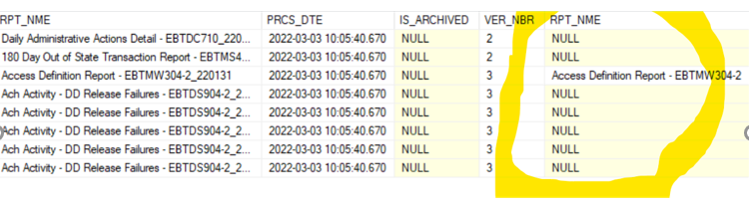
- In Where condition we have used Concat condition to filter the already generated PDF entries by comparing it with its own text file as below
CONCAT(FLE.LVL1,LVL2,LVL3,FLE.RPT_NME)
NOT IN(SELECT CONCAT(LVL1,LVL2,LVL3,RPT_NME)
FROM TB_SPF_FILE_SORT_PDF where FILE_EXT = 'PDF') AND FLE.FILE_EXT = 'TXT'
Remember :
- If we don’t have entry in State dim table then the entries will not taken into account for PDF generation because we have main column in query with this table . So PDF will not generate.
- But if we don’t have entry in Meta data table, then the entries will taken into account. This is because we have used Isnull condition for all the column in query related to this table.
So even if we don’t have entry in Meta data table it will generate PDFs
Script Task Query 2 – Explanation:
INSERT INTO TB_SPF_FILE_SORT_PDF SELECT
'" + pdfFilename.Replace(serverPath, localPath) + "',
GENERATED_DATE,
GENERATED_TIME,
DATETIME,
'PDF',
LVL1,LVL2,LVL3,RPT_CAT,RPT_NME,GETDATE(),
IS_ARCHIVED,VER_NBR
FROM TB_SPF_FILE_SORT_PDF
WHERE FILENAME1= '" + textfilefullpath.Replace(serverPath, localPath) + "';

DELETE FROM TB_SPF_FILE_SORT_PDF WHERE FILENAME1 ='' AND FILE_EXT='PDF'

- In this query we will make PDF entries for their respective Txt file entries once after the PDF file generation completes.

- In this script task, we will write DSRowCount text, Initially write all the txt file entries that fetched from table, and again it will overwrite the same file with total count of these entry.
- Then DSinsert text file will generate, for every pdf file entry into table, this text file will overwritten for every file.
- The DSrow will written once the execution entered into try block

Script task

